CHAPTER IV
RESULT AND DISCUSSION
This chapter showcases the findings and the discussion to support the methodology applied in reaching the objectives. The presentation is typically directed by the particular objectives or problem of the research study.
Results by Objectives of the Study
1. A web system for Innovation and Technology Support Office (ITSO) that will assist in registering and tracking intellectual property.
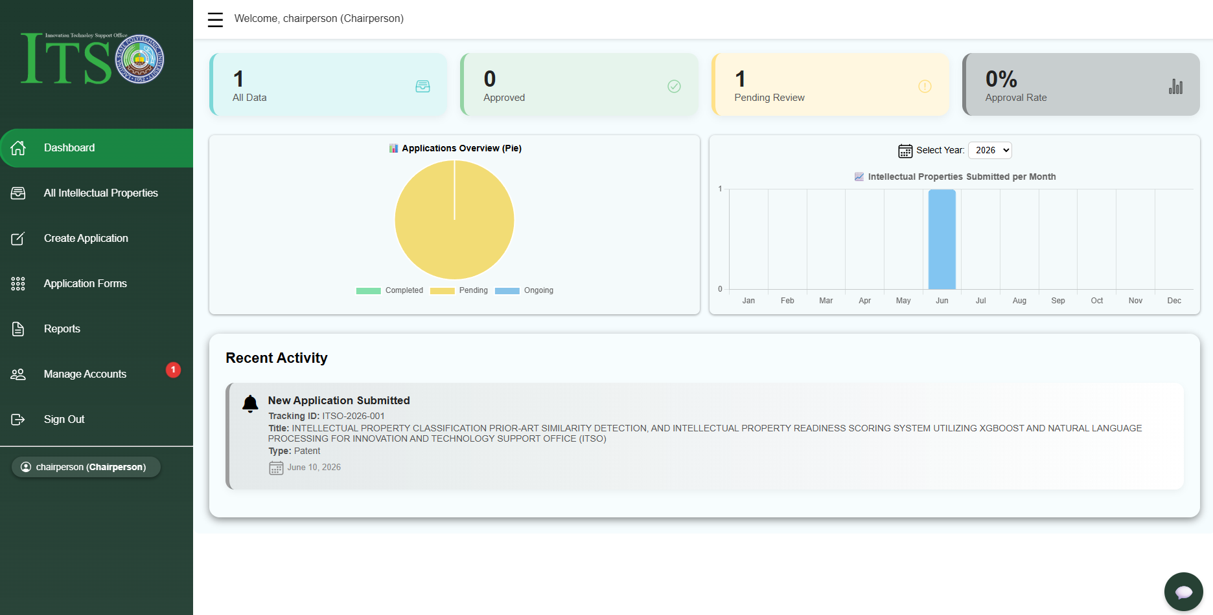
Figure 16. Chairperson Dashboard Interface
This module, the Chairperson Dashboard Interface serves as the primary control center for the Innovation and Technology Support Office upon logging into the system. This module actively retrieves and displays the real-time overview of the intellectual property applications submitted within the university. It includes the summary cards for total applications for the approved application and pending reviews and also the approval rate, alongside a visual pie chart for the application status overview. Through this interface, the Chairperson can efficiently navigate to other core modules such as all intellectual property application for reviewing the application, create application, application forms, reports and account management, effectively fulfilling the management workflow of the office.
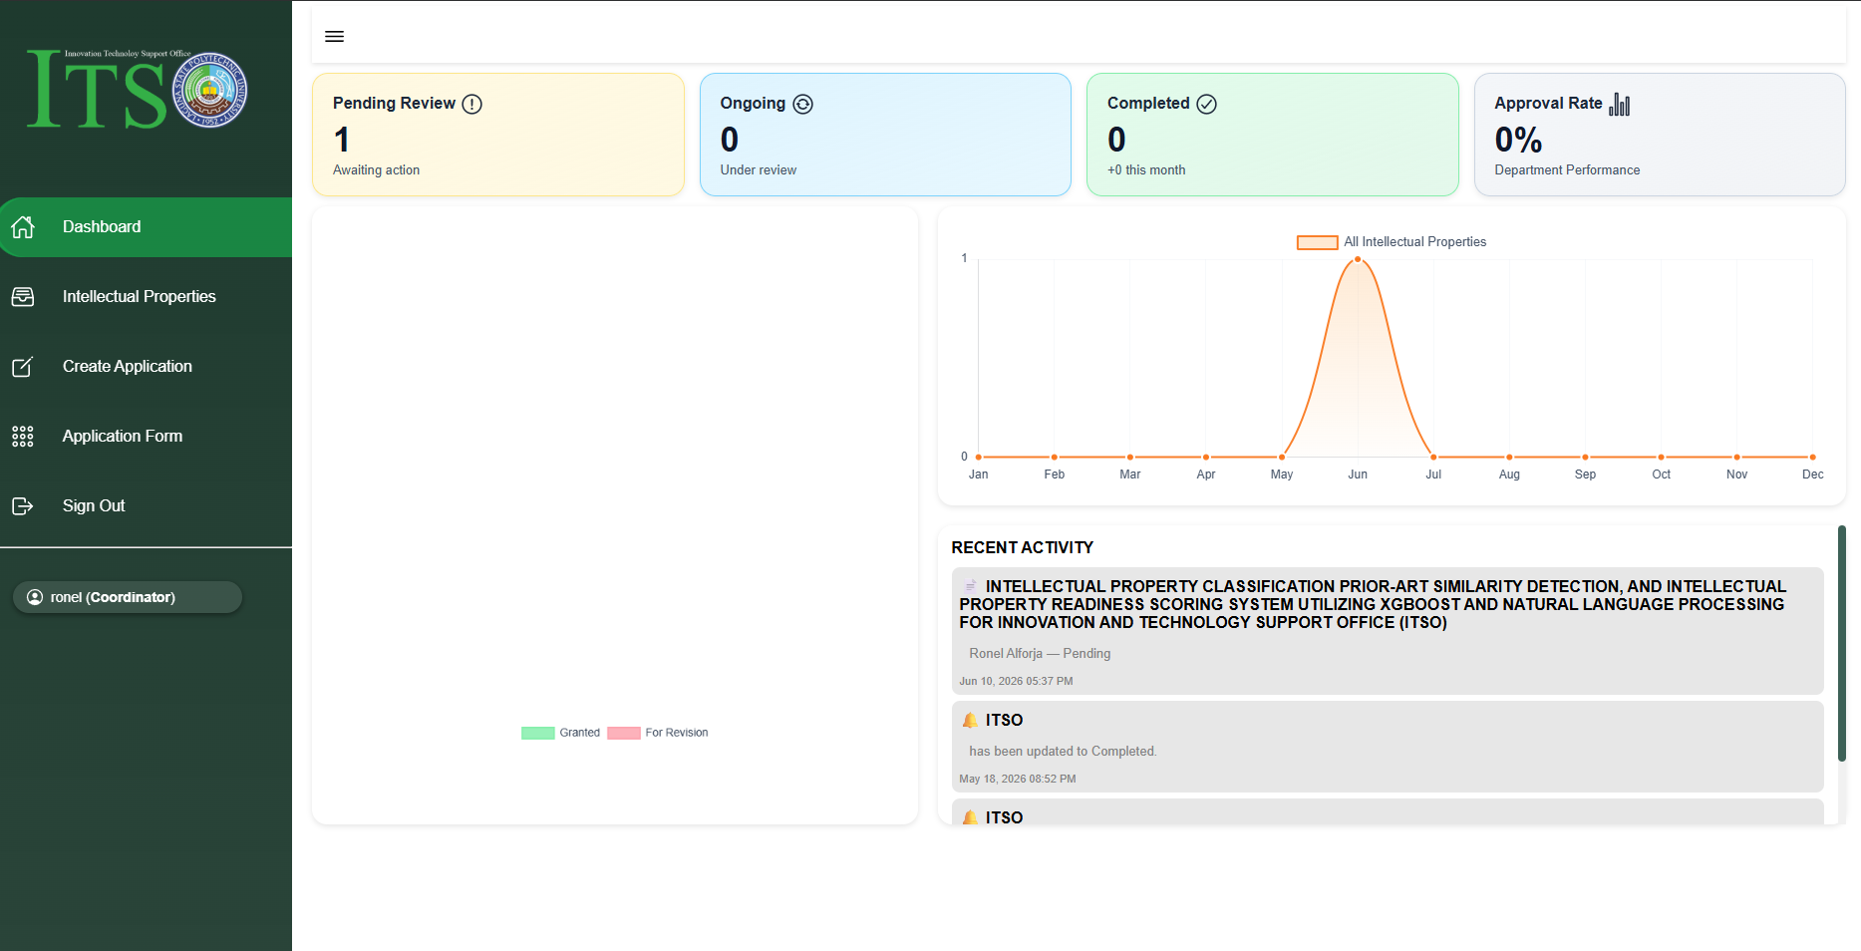
Figure 17. Coordinator Dashboard Interface
Figure 17 shows the Coordinator Dashboard Interface. This view is customized for specific college coordinators. Unlike the Chairperson who can view all submissions across the university, the Coordinator can only see the data from their assigned department. The metric cards, timeline graph, and recent activity log automatically filter and display information belonging exclusively to their respective college. This setup ensures that all coordinators will only monitor their own department's intellectual property applications, to keep the data organized and secured.
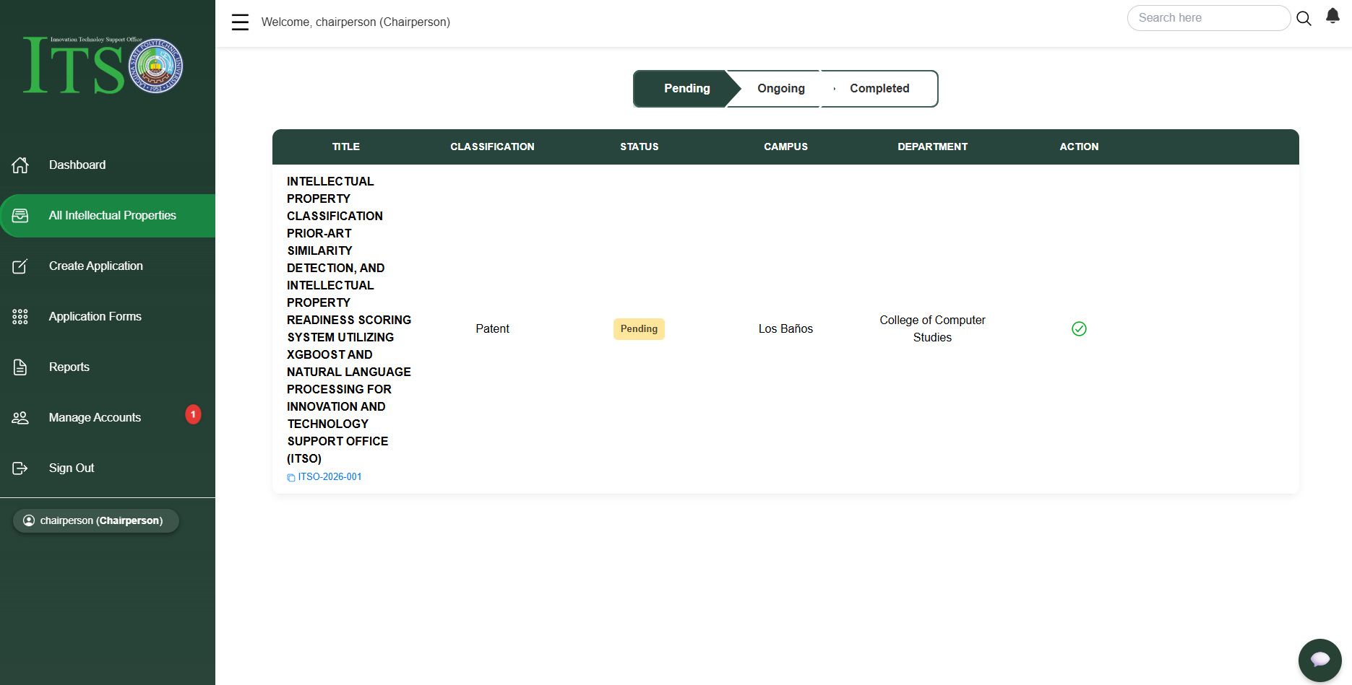
Figure 18. All Intellectual Properties Interface
Figure 18 illustrates the All Intellectual Properties Interface from the Chairperson's view. This module serves as a centralized repository that actively retrieves and lists all submitted intellectual property applications. The interface organizes these applications into different tabs based on their processing state Pending, Ongoing, and The Completed. As shown under the title column, each application entry displays its complete metadata, including the project classification, the current status, the originating campus, and also the department. Through this interface, the Chairperson is authorized to review and manage each application, ensuring an organized system for monitoring the intellectual property pipeline.
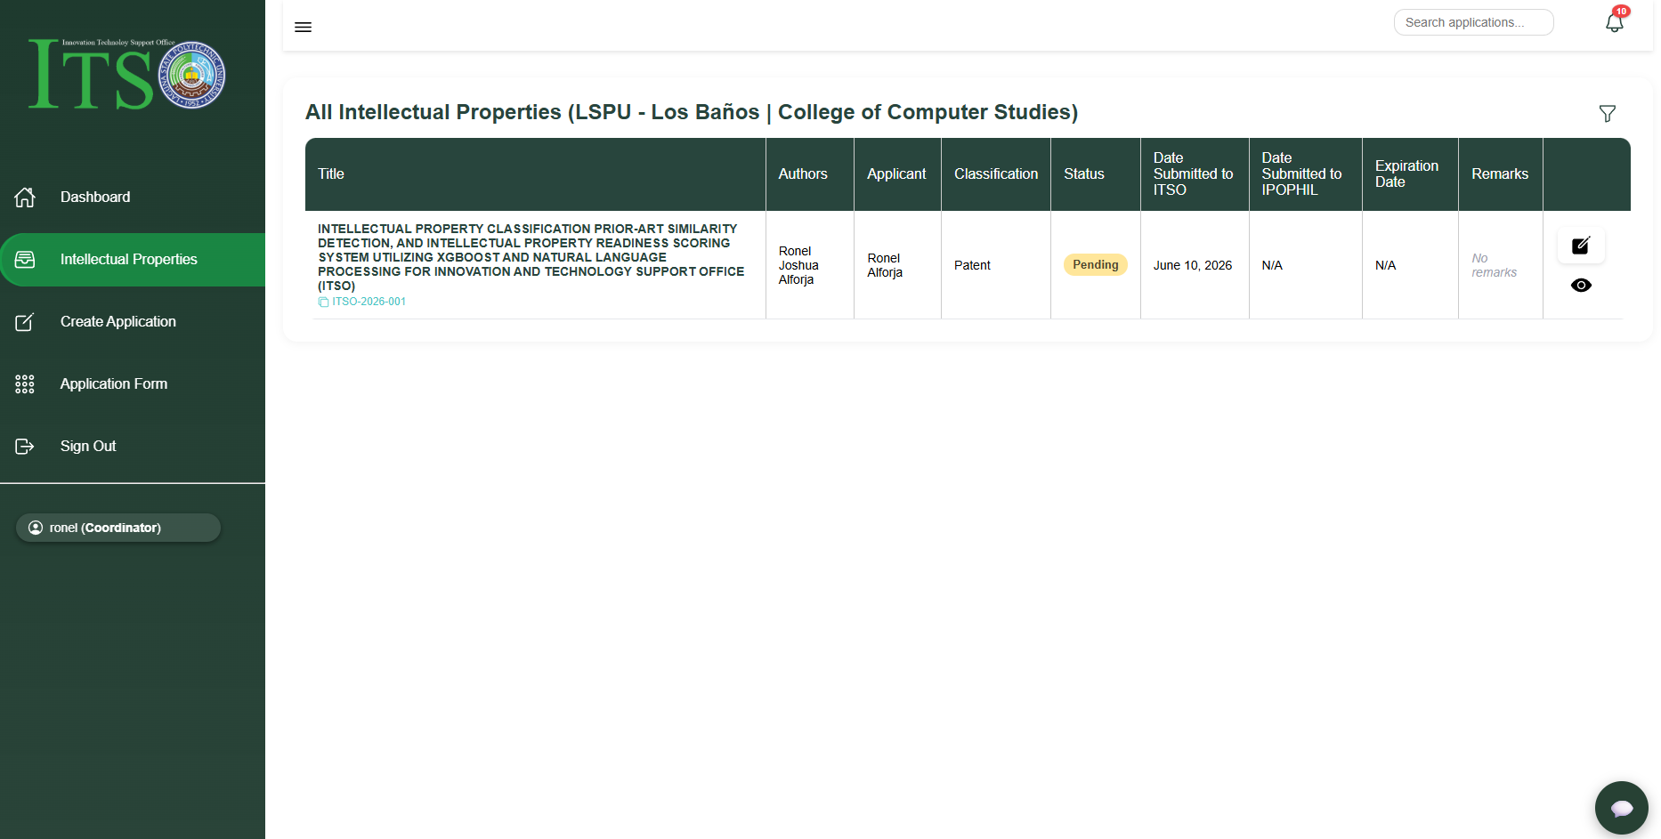
Figure 19. Coordinator Intellectual Properties Interface
Figure 19 shows the Intellectual Properties Interface for the Coordinator. This module restricts access based on the coordinator’s campus and college. The interface displays a detailed data table showing the application title, authors, applicant name, classification, status, and remarks. Through the action buttons, the coordinator is permitted to view the submitted applications as they are. Additionally, the Coordinator can edit or modify the application details if the Chairperson returns the submission for revision. This feature ensures a controlled process for correcting and updating application data.
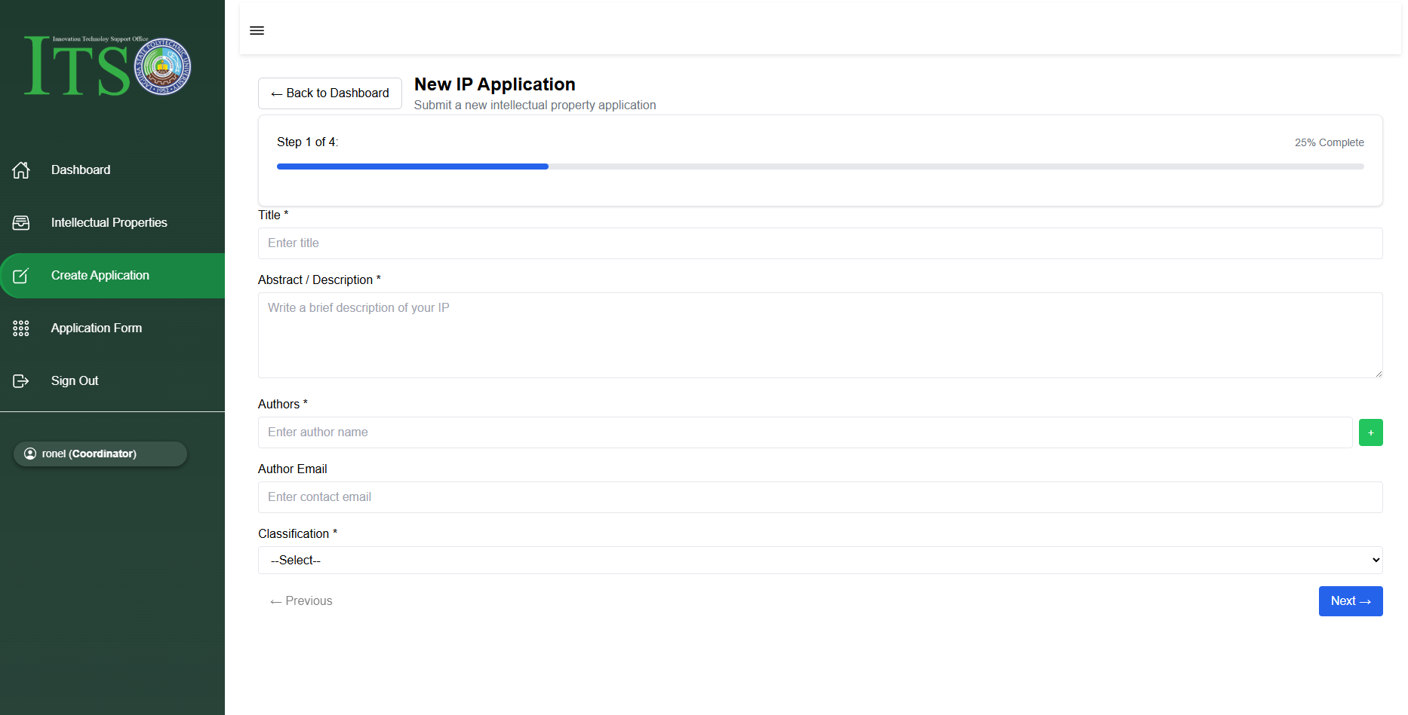
Figure 20. Create Intellectual Property Interface
Figure 20 illustrates the Create Intellectual Property Application Interface, which is accessible to both the Chairperson and the Coordinator for submitting new intellectual property application. To ensure data accuracy and user convenience, the creation module uses a multi-step form progress tracker, shown here at Step 1. This interface serves as the primary data entry point create process where users input essential application details, including the project title, abstract or description, author names, email addresses, and technology classification. The abstract and description fields capture the raw text data that will be fed directly into the integrated SBERT model for prior-art similarity checking and the XGBoost model for readiness scoring.
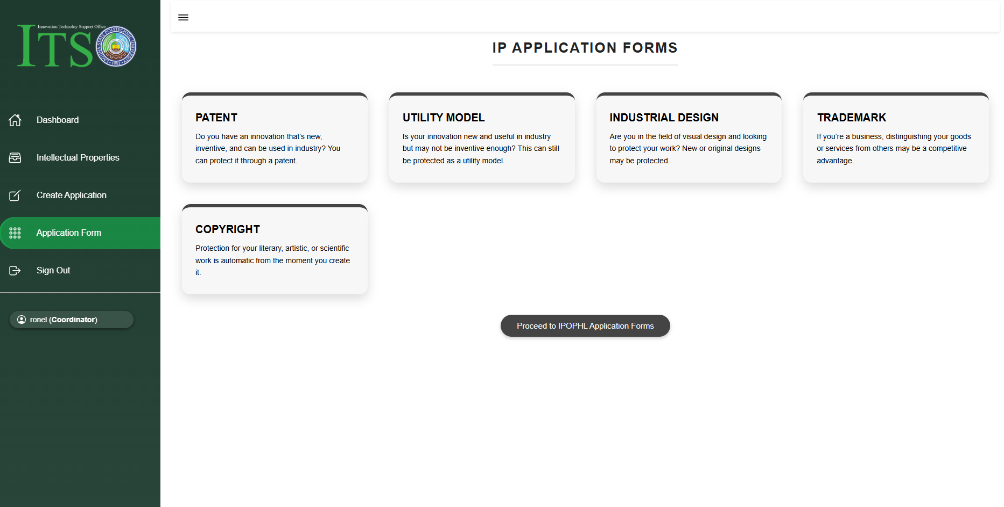
Figure 21. Intellectual Property Application Form
Figure 21 shows the Intellectual Property Application Forms Interface, which provides users with direct access to the official intellectual property application forms, categorized into Copyright, Patent, Utility Model, Industrial Design, Trademark. Initially, the system was designed with hardcoded downloadable files for each card. but we have an issue, because the Intellectual Property Office of the Philippines (IPOPHL) frequently updates these documents annually so the fixed files would cause the system to store outdated forms. To resolve this and ensure the system remains sustainable that's why we integrate the direct button labeled 'Proceed to IPOPHL Application Forms'. This button links directly to the forms page on the official IPOPHL website, if we linking to specific forms by category would trigger OneDrive security protocols requiring a login, so we chose to direct users to the main IPOPHL forms page instead eliminating the need for additional login steps while ensuring users always have access to the latest, legitimate, and updated regulatory documents.
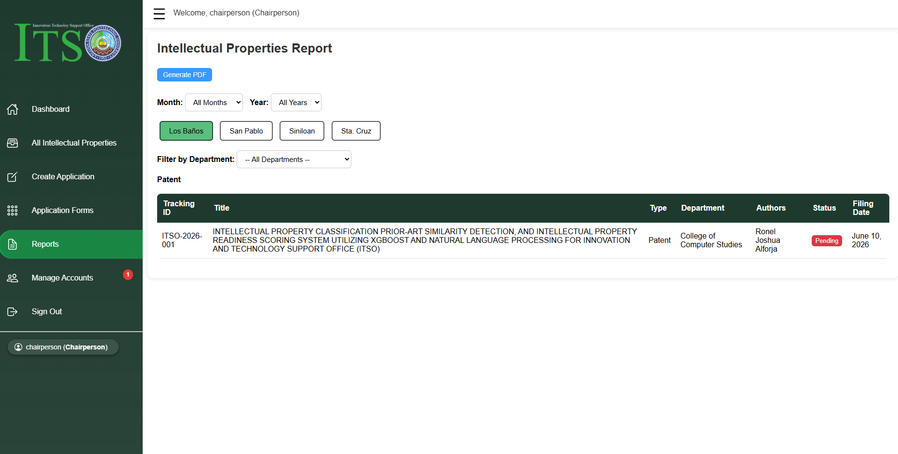
Figure 22. Chairperson Reports Interface
Figure 22 illustrates the Intellectual Properties Reports Interface from the Chairperson’s view. This module serves as the reporting engine of the web system, allowing the Chairperson to filter intellectual property data dynamically by Month, Year, Campus (Los Baños, San Pablo, Siniloan, and Sta. Cruz), and specific Departments. The system compiles all matching records into a structured data table that displays the key information, including the unique tracking ID, application title, department, authors, processing status, and filing date. Additionally, the 'Generate PDF' button function, that is automates the export of filtered data into the downloadable and printable report for the office official record keeping.
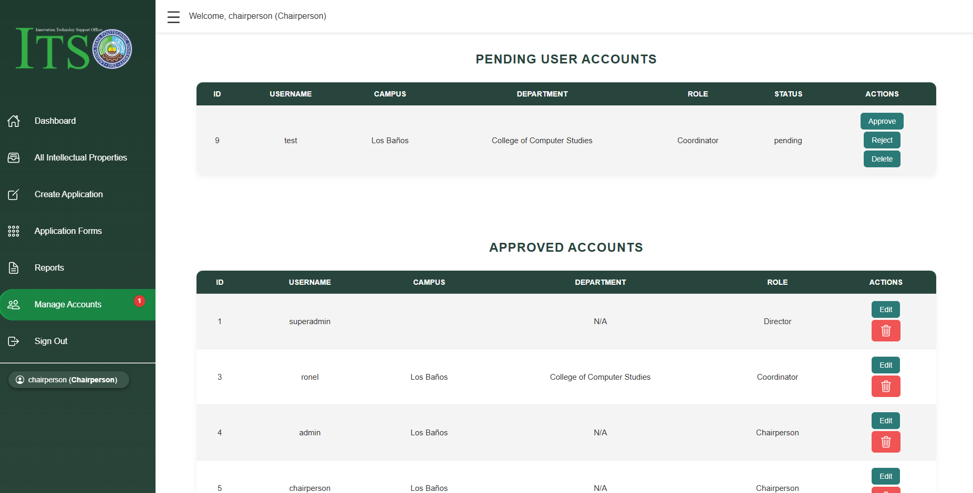
Figure 23. Manage Account Interface
Figure 23 shows the Manage Accounts Interface from the Chairperson’s view. This module is divided into two main tables to handle user security: 'Pending User Accounts' and 'Approved Accounts'. The top table handles account approval, where the Chairperson can view the all the registration requests and select 'Approve', 'Reject', or 'Delete'. The bottom table displays all currently approved or registered active accounts, along with their assigned username, and campus, and department, and also role such as Director, Coordinator, or Chairperson. Through the action buttons on the approved list, the Chairperson is authorized to edit account name and password or completely remove a user from the system, ensuring full administrative control over the coordinator access.
2. A machine learning model utilizing Natural Language Processing (NLP) using SBERT for prior-art similarity detection, along with XGBoost for readiness scoring to determine patentability and filing readiness.
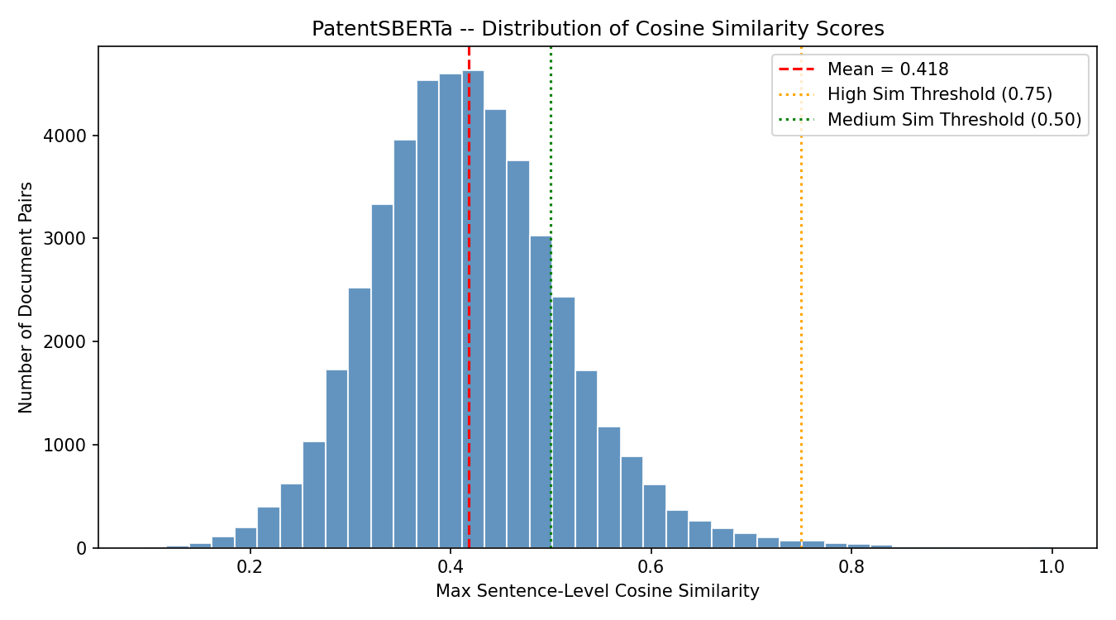
Figure 24. PatentSBERTa Cosine Similarity Score Distribution
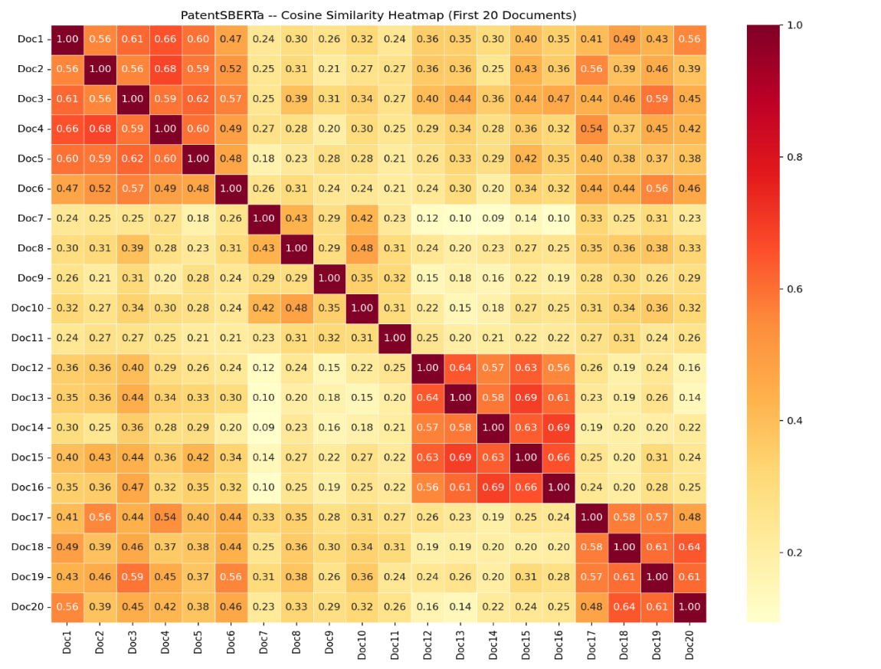
Figure 24 shows the Distribution of Cosine Similarity Scores generated by the model PatentSBERTa across all 124,750 unique document pairs from the dataset that we gathered from the different patent websites. This chart measures how conceptually similar the patent titles and abstracts are to one another by plotting the maximum sentence-level cosine similarity values against of the total number of document pairs. The measured evidence reveals a normal, normal distribution with a central mean of 0.418, indicated by the red dashed line, which is proves that the patent records cover a broad diverse range of unique technological topics rather than being highly repetitive. The vast majority of the data points fall strictly within the low similarity region below the 0.50 green dotted line, which validates that the dataset provides highly rich and assorted and also distinct technical text data profiles. Furthermore, the extremely low frequency of document pairs approaching or crossing the 0.75 orange dotted threshold mathematically confirms that there are virtually no direct duplicate records or plagiarized entries within the repository, ensuring a highly robust feature matrix for the subsequent machine learning pipeline.

Figure 25. PatentSBERTa – Cosine Similarity Heatmap (1st 20 Documents)
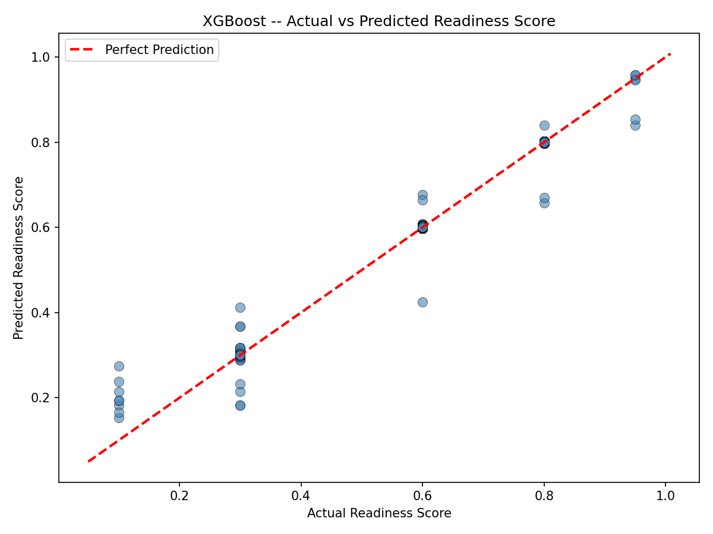
Figure 25 shows the Cosine Similarity Heatmap generated by PatentSBERTa for the first 20 documents in the dataset. This matrix measures the exact pairwise semantic relationships between individual patents by mapping their cosine similarity values on a color-coded scale from yellow to dark red. The factual data reveals a perfect dark red diagonal line consisting strictly of 1.00 scores, which verifies the mathematical consistency of the encoder when comparing each document to itself. Distinct orange-red micro-clusters are also visible across the matrix most notably between Doc12 and Doc16 with elevated scores ranging from 0.56 to 0.69 proving that the system successfully identifies patents that share dense technical vocabularies or belong to a highly similar technology domain. Conversely, the surrounding light-yellow tiles display much lower scores between 0.14 and 0.30, confirming PatentSBERTa's strong capability to separate completely unrelated technical topics and provide distinct feature boundaries for the subsequent predictive stages.
Figure 26. XGBoost – Actual vs Predicted Readiness Score
Figure 26 shows the Actual vs Predicted Readiness Score Scatter Plot generated during of the testing phase of XGBoost regression model. This visualization measures that the predictive accuracy of the pipeline by plotting the true ground-truth readiness scores against the continuous values predicted by the system, using a red dashed line to represent the threshold for a perfect prediction. The empirical data reveals a strong linear alignment where the blue semi-transparent data points cluster tightly along the ideal diagonal across all discrete target increments including 0.1, 0.3, 0.6, 0.8, and 0.95. This layout demonstrates the low predictive variance and excellent model generalization across the entire dataset, despite of a few understated outlier variations under-predicting around the 0.60 mark. Furthermore, the model maintains its predictive stability uniformly from lower to higher maturity bounds without showing the extreme bias, proving that the integration of PatentSBERTa embeddings and the XGBoost regressor forms a highly robust framework for automated technology readiness evaluation.
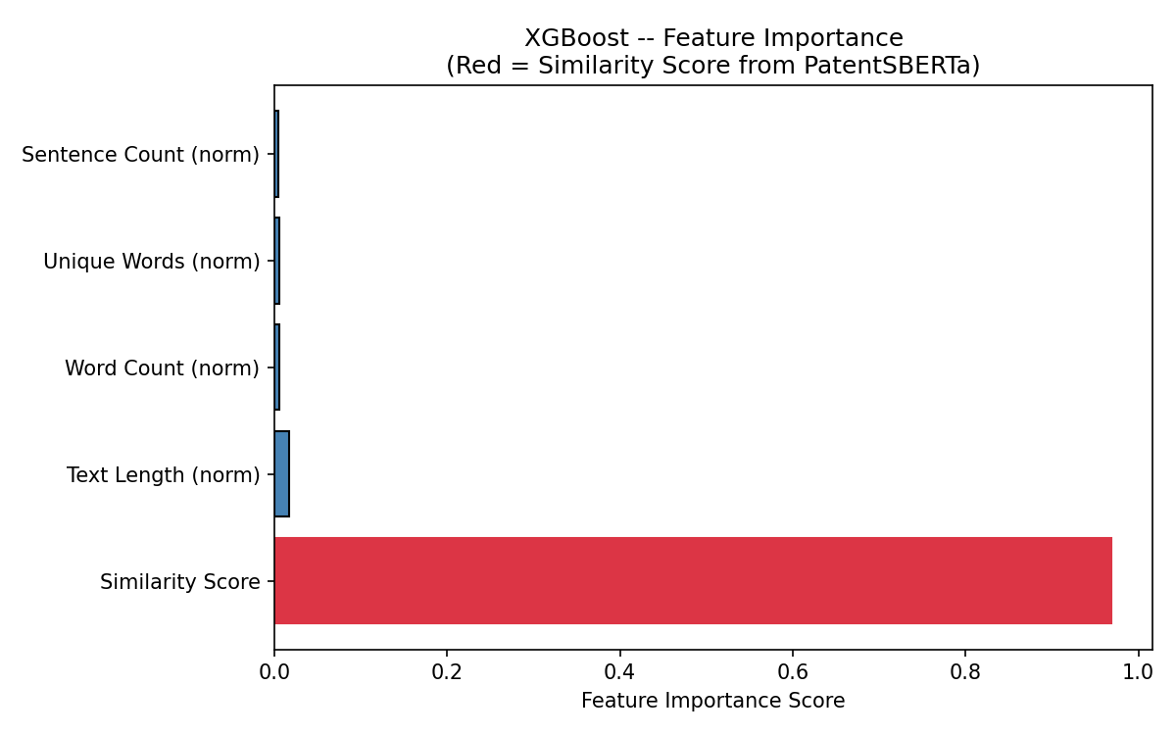
Figure 27. XGBoost – Feature Importance
Figure 27 shows the Feature Importance Plot generated during of the training phase of XGBoost regression model. This chart measures the relative mathematical contribution and weight of each independent input variable including both metadata properties and semantic metrics on the system's final determination of a patent's readiness score. The measured evidence reveals the absolute dominance of semantic similarity, where the similarity score derived from PatentSBERTa (highlighted in red) captures an overwhelming feature importance metric of 0.9684. Conversely, basic structural text markers demonstrate negligible importance weights within the machine learning pipeline, where normalized text length yields 0.0164, normalized word count yields 0.0055, normalized unique words yields 0.0051, and normalized sentence count yields 0.0046. This massive variance distribution mathematically confirms that the predictive engine relies almost entirely on the actual contextual meaning of the patent abstract rather than superficial properties like document length or typographical counts.
Table 11. PatentSBERTa Encoder Statistic Similarity
Statistical Metric | Statistical Value | Distribution Breakdown | Percentage Share
Total Processed Documents | 307 | Low Similarity (< 0.50) | 82.1%
Total Unique Pairs Compared | 46,971 | Medium Similarity (0.50 – 0.74) | 17.3%
Average Cosine Similarity | 0.4184 | High Similarity (≥ 0.75) | 0.5%
Median Cosine Similarity | 0.4129
Maximum Similarity Score | 1.0000
Minimum Similarity Score | 0.0939
Standard Deviation (SD) | 0.0968
Table 11 shows the Statistical Summary for the PatentSBERTa semantic similarity encoder based on the real patent data extracted from Espacenet, Google Patents, and WIPO. This module measures the semantic consistency and diversity of the repository by conducting a complete pairwise comparison across 46,971 unique document pairs derived from the 307 processed records. The data from Espacenet, WIPO, and Google Pantents reveals a highly balanced distribution, where the Average Cosine Similarity produce 0.4184, and the Median Cosine Similarity produce 0.4129, and also the Standard Deviation produce 0.0968, indicating that the system effectively maps a wide variety of unique patent topics with minimal operational noise. Structural distribution metrics further confirm that the repository's integrity, where low-similarity documents capture the largest share at 82.1%, related medium-similarity works produce 17.3%, and potential duplicate rows at the high-similarity threshold account for an isolated 0.5%. This statistical layout mathematically guarantees that the language model successfully extracts distinct, high-quality semantic variations across the real-world patent data, providing a solid features engine for the subsequent predictive pipeline.
Table 12. XGBoost Regressor Evaluation Metrics
Evaluation Metric | Computed Value | Model Interpretation / Rating
Total Test Documents Used | 62 | Representative Validation Subset
Total Test Pairs Evaluated | 1,891 | Out-of-Sample Evaluation Bounds
Mean Absolute Error (MAE) | 0.0022 | High Precision (Negligible Average Error)
Mean Squared Error (MSE) | 0.0001 | Excellent Stability (Minimal Outlier Variance)
Root Mean Squared Error (RMSE) | 0.0118 | Exceptional Prediction Proximity
Coefficient of Determination (R² Score) | 0.9919 | Excellent Fit (Explains 99.19% of Variance)
Table 12 shows the NLP Evaluation Metrics for the XGBoost readiness scoring model during its validation phase using real patent datasets. This module measures the continuous predictive variation of the machine learning pipeline by calculating of the mathematical distance between the predicted scores and the actual labels across 1,891 independent test pairs. The empirical data reveals the exceptional calibration, where the Mean Absolute Error (MAE) produce 0.0022 and the Root Mean Squared Error (RMSE) produce 0.0118, confirming that the system’s average prediction discrepancy remains under one percent. Furthermore, the model demonstrates high system stability with a Mean Squared Error (MSE) of 0.0001, proving that this algorithm produces almost no severe outlier estimation errors. This outstanding operational precision is formally validated by the Coefficient of Determination (R² Score) of 0.9919, which statistically proves that the combined architectural integration of a PatentSBERTa embeddings and normalized metadata features successfully explains 99.19% of the variance in the target patent readiness levels.
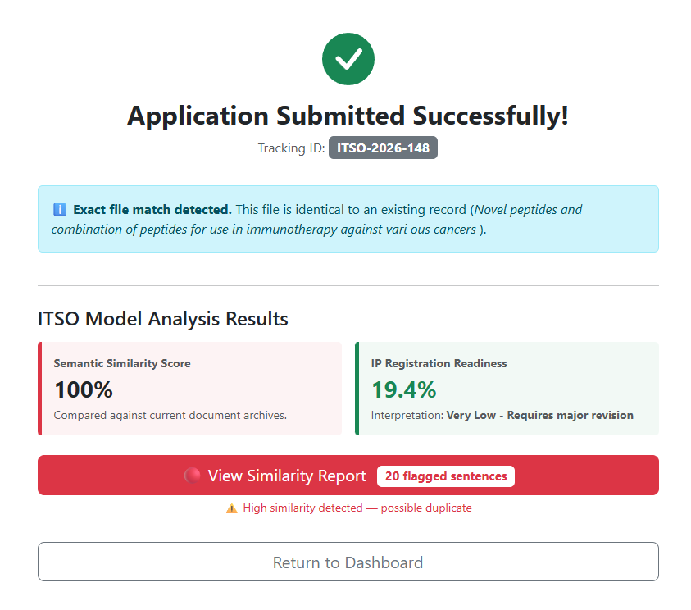
Figure 28. System Model Interface
Figure 28 shows the model analysis results panel displaying the system’s reaction under of a full semantic duplicate scenario. This interface component demonstrates of how the combined pipeline handles identical inputs by analyzing the newly submitted document under tracking ID ITSO-2026-148 against current system records. The algorithm flags a Semantic Similarity Score of 100% because the exact same file is already saved and existing in the system’s database repository.
It is important to emphasize that the model does not rely on simple word-by-word matching similarity. Instead, because PatentSBERTa uses deep contextual cosine similarity, the system can generate normal to elevated similarity percentages even if the sentences do not use the exact same words. If the encoder determines that a newly submitted sentence is merely a paraphrased version of an existing record, the machine learning pipeline will automatically detect the semantic relationship and flag it accordingly. Consequently, due to this high duplicate detection, the integrated XGBoost model automatically penalizes the application, dropping the IP Registration Readiness score down to 19.4% with an interpretation value of Very Low, mathematically proving that the platform successfully distinguishes deep contextual meaning from superficial keyword variations.
3. To evaluate the developed web-based application through AI/ML model performance metrics, ISO 25010 software standard, and Technology Acceptance Model (TAM) for user acceptance.
Evaluation Result using TAM and ISO 25010
The results are collected from the respondents who are the personnel that will use the system.
Table 13. Perceived Usefulness
Perceived Usefulness (PU) | Mean | SD | Interpretation
1. The web-based system significantly accelerates the completion of my assigned tasks in the application process.
2. The system’s role-specific view effectively simplifies how I monitor and track the status of innovation documents within my scope of responsibility.
3. The platform improves productivity when handling, updating, or responding to application revisions and resubmissions.
4. The system's automated similarity analyses and readiness scoring features provide high-quality data insights that enhance the evaluation of applications.
5. Overall, this web-based platform is a highly useful tool for managing my designated administrative duties within the ITSO.
COMPOSITE MEAN
n=, “”: highest to lowest as follows: four (4) – Strongly Agree (3.26 – 4.00), three (3) – Agree (2.51 – 3.25), two (2) – Disagree (1.76 – 2.50), and one (1) – Strongly Disagree (1.0 – 1.75)
//

Table 14. Perceived Ease-of-Use
Perceived Ease-of-Use (PEU) | Mean | SD | Interpretation
1. Learning to operate the web-based system is easy and straightforward for me.
2. I find it easy to get the system to do what I want it to do, whether submitting documents or processing reviews.
3. The layout of the automated similarity analyses and readiness scores is clear and easy to understand.
4. It is easy to navigate the system when an application needs to be updated or returned for revision.
5. Overall, I find the web-based ITSO system easy to use.
COMPOSITE MEAN
n=, “”: highest to lowest as follows: four (4) – Strongly Agree (3.26 – 4.00), three (3) – Agree (2.51 – 3.25), two (2) – Disagree (1.76 – 2.50), and one (1) – Strongly Disagree (1.0 – 1.75)
//
Table 15. Attitude
Attitude (Towards Using the System) | Mean | SD | Interpretation
1. Using the web-based system for managing ITSO applications is a good idea.
2. I would feel positive about using this system to create my application.
3. Having a platform to track submission status would make the application process less of a hassle.
4. I find the automated tools (similarity analysis and scoring) convenient to have.
5. Overall, I think using this web-based system would be very helpful for the faculty.
COMPOSITE MEAN
n=, “”: highest to lowest as follows: four (4) – Strongly Agree (3.26 – 4.00), three (3) – Agree (2.51 – 3.25), two (2) – Disagree (1.76 – 2.50), and one (1) – Strongly Disagree (1.0 – 1.75)
//

Table 16. Behavior
Behavior (Intention to Use the System) | Mean | SD | Interpretation
1. I intend to use the web-based system as much as possible for processing future applications.
2. I would prefer using this platform over traditional manual submission methods.
3. I plan to use the system’s automated tools to check my document's readiness before final submission.
4. I will recommend the use of this system to my co-faculty members who are doing research.
5. Overall, I have a strong intention to use this web-based platform for my future ITSO transactions.
COMPOSITE MEAN
n=, “”: highest to lowest as follows: four (4) – Strongly Agree (3.26 – 4.00), three (3) – Agree (2.51 – 3.25), two (2) – Disagree (1.76 – 2.50), and one (1) – Strongly Disagree (1.0 – 1.75)
//
Table 17. Post Evaluation Result
Characteristics | Mean | SD | Interpretation
Functional Suitability
Usability
Reliability
Performance Efficiency
Security
Compatibility
Maintainability
Flexibility
Safety
Overall Mean
n=3 IT experts
//
System and Software Testing Results
This section shows the result of the actual logs and the performance metrics that we gathered during the overall testing of the web-based application system. To make it sure that the system meets all of the technical requirements and runs safely before the deployment of the system, it underwent a series of tests: Software Testing, Compatibility Testing, Unit Testing, Integration Testing, Performance Testing, and Stress Testing. These evaluations are very important to verify that the front-end interface and the secure database and also the AI pipeline powered by PatentSBERTa and XGBoost work together perfectly. Eventually, these tests confirm that the platform can process data quickly and stay stable even when multiple users are active at the same of time.
A. Unit Testing
This test focuses on verification at the smallest, isolated components of the software design, such as individual functions, classes, or database operations. It ensures that the core mathematical, conditional, and logical operations within the source code function accurately before being combined with other modules.
Table 18. Test Conducting for Unit Testing
Unit Test ID | Steps | Expected Results | Actual Results | Remarks
1 | Test the login functionality for both the Chairperson and Coordinator roles to verify if they are directed to their respective designated dashboards. | The system will direct them to their account dashboard, where they will only see the modules designated for their account. | Both the chairperson and the coordinator are directed to their respective dashboards. | Passed
2 | Verify registration process before login. | User should be able to create an account and access the dashboard upon successful registration. | User registration and dashboard access were successful. | Passed
3 | Test Create Application Module by submitting new intellectual property applications with complete and incomplete data. | The system should submit the complete applications and alert the user of missing information. And also show the result of Similarity Score and Readiness Score. | The create application module successfully submit the complete applications and displayed alerts for incomplete submissions. And showed the result of model. | Passed
4 | Test Chairperson account to review, verify, and update application status. | Chairperson should be able to review application and verify the documents, and update status (accepted, for revision) | Chairperson was able to process applications and update statuses successfully. | Passed
5 | Check the All Application module for real time application tracking by Coordinator’s | Coordinators should be able to view the current application status if accepted or for revision | Application statuses were displayed in real time, and the notification were sent successfully. | Passed
6 | Test Chairperson and Coordinator’s Dashboard for monitoring all active application. | The dashboard should display a list of pending, ongoing, completed/approved applications. | The dashboard displayed accurate and updated application data. | Passed
7 | Test system security and data protection during login and application submission | The system should protect the user account/credentials and also the application data from unauthorized access. | All user credentials were securely stored and encrypted. No unauthorized access occurred. | Passed
Table 18 shows the actual results from the initial unit testing phase of the system. In this stage, we tested seven main areas including user login, module workflows, and basic security and all of them passed without any technical issues. When logging in the system correctly split the roles making sure that both of the Chairperson and the Coordinator were sent straight to their specific dashboards with the right access permissions. The Create Application Module also worked as expected. It processed complete submissions smoothly threw clear alerts when there was missing info and correctly displayed the generated scores. On top of that, the user data and login credentials were encrypted properly so meaning the system can prevent unauthorized access. Because every isolated feature passed this round of testing, we can confidently say that the core code is stable enough to move forward with integration testing.
B. Integration Testing
The integration testing was done to see if the different parts of the system worked well together. We wanted to make sure that the data moved smoothly and that the parts interacted with each other in the way. Each test looked at how a specific part of the system interacted with the dashboard. The dashboard is the point that connects most of the features of the system. We did this because the dashboard is the place where all the parts of the system come together. The integration testing checked how each part of the system worked with the dashboard.
Table 19. Test Conducting for Integration Testing
Integration Test ID | Steps | Expected Results | Actual Results | Remarks
1 | Integrate Login Module with the dashboard module. Test if only authenticated users can access and create applications. | Unauthenticated users are redirected to the login page; authenticated users land on the dashboard and can access the "create application" form. | Successfully logged in using both Chairperson and Coordinator accounts and accessed their respective dashboards. After logging out and pasting the Chairperson dashboard URL directly, the system redirected back to the login form with no unauthorized access. | Passed
2 | Integrate the Create Application Module. Submit an application with an uploaded abstract/document and check if similarity results are returned. | PHP successfully sends the details into database and extracted text to the Flask API and receives a similarity score response without connection errors or timeouts. | After submitting an application with an attached abstract, the system showed a loading indicator, then successfully returned and displayed the similarity and readiness result. | Passed
3 | Went to the dashboard and tried opening and updating the account details through Manage Account. | Manage Account should open properly from the dashboard, and any changes made should be saved. | Opened Manage Account from the dashboard without any issue, made changes to the account details, and the updates were saved successfully. | Passed
4 | Checked the Application List from the All Intellectual Properties using both the Coordinator and Chairperson accounts to see if the correct applications show up for each role. | The Coordinator should only see applications from their own department, while the Chairperson should see all applications across the campus. | The Coordinator account only showed applications from its own department, and the Chairperson account showed applications from the whole campus, just as expected. | Passed
5 | Tried generating a report using data pulled through the dashboard. | The report should generate correctly and reflect accurate data. | Clicked "Generate PDF" from the report module and the exported report showed accurate data. | Passed
Table 19 shows the integration testing to see if all the parts of the system worked well together. We did not just test them one by one. We tested them all connected. The first test was about the login and dashboard. We wanted to make sure that only people who were logged in could get to the dashboard and create an application. We tried to get to the dashboard link after we logged out. It sent us back to the login page, which is what we wanted to happen. Next, we tested the application submission process. We uploaded an application with something attached to it. We checked if the system could send the details to the database. We also checked if the system could give us a result without any problems. The Manage Account feature was also tested from the dashboard. We wanted to see if we could open, edit and save account details correctly. We used the application list to test the Coordinator and Chairperson accounts. We wanted to see if they could only see what they were supposed to see. The Coordinator could only see applications from their department and the Chairperson could see everything from the whole campus. Lastly, we tested the report generation feature. We wanted to see if the report we got had the right and most recent data, from the system. All the integration tests worked, which means that all the parts of the system are working together like they should. We tested the login and dashboard the application submission process, the Manage Account feature, the application list and the report generation feature. They all worked well. The application submission process and the report generation feature were especially important. They worked without any problems. The system is working well. All the integration tests passed, which is what we wanted to see and it shows that the system is working like it should and the integration testing of the system was successful.
C. Compatibility Testing
This compatibility testing phase ensures that the developed web application is remains functional and visually consistent and also operationally stable across various platforms, web browsers, and operating systems specifically Windows 11 and 10. This process guarantees that all users experience consistent features, regardless of the software or hardware architecture used to access the system.
Table 20. Cross-Platform and Multi-Browser Compatibility Testing
Web | Version | Design | Functionality | Performance
Microsoft Edge | 151.0.4129.59 | YES | YES | YES
Google Chrome | 151.0.7922.72 | YES | YES | YES
Brave Browser | 151.1.93.129 | YES | YES | YES
Firefox | 153.0.3 | YES | YES | YES
Table 20 shows that when we tested this across various browsers such as Microsoft Edge, Google Chrome, Brave Browser, and Mozilla Firefox, it was successful and the design remained intact and functionality stayed consistent and the performance remained the same. The only thing we noticed during this testing was the default alert style, but that is normal, as each browser has its own design for alert pop-up. We also the same results across different operating systems.
D. Stress Testing
Stress testing is performed to determine of how the system behaves when it experiences so many simultaneous requests to ensure that it will remain stable and reliable under the heavy load.
Table 21. Test for Stress Testing
Stress Test ID | Steps | Expected Results | Actual Result | Remarks
1 | Execute a load test simulating 50 concurrent users making a total of 2,000 successful login requests via ApacheBench tool using valid credentials (username and password). | The system should handle the concurrent requests successfully. The error rate must be 0% and the average response time should be within acceptable limits (< 2 seconds). | Throughput: 201.86 requests/sec  - Avg. Response Time: 0.25 sec  - Failed Requests: 0 (0.00% Error Rate)  - Max Response Time: 0.36 sec | Passed
2 | Execute a load test simulating 20 concurrent users making a total of 100 entry creation requests via ApacheBench tool to the create application module. | The system should successfully process and save the data entries. The error rate must be 0%, though a slight dip in response time is acceptable due to database write operations. | Throughput: 3.13 requests/sec  - Avg. Response Time: 6.39 sec  - Failed Requests: 0 (0.00% Error Rate)  - Max Response Time: 8.09 sec | Passed
3 | Execute a spike load test simulating 100 concurrent users making a total of 250 pages requests without POST data to measure base page loading capacity. | The web server should quickly serve the base structure of the creation page to all simultaneous users without encountering gateway or connection timeout errors. | Throughput: 13.66 requests/sec  - Avg. Response Time: 7.32 sec  - Failed Requests: 0 (0.00% Error Rate)  - Max Response Time: 8.46 sec | Passed
Table 21 shows the results of the stress testing we did for a web-based system that we developed for the Innovation and Technology Support Office (ITSO). Our results show that the system remains stable even under very heavy workloads. We tested the system to see how it handles simultaneous requests from users. We used ApacheBench (ab), we tested it on the login module and the create application pipeline to test their limitations. When we tested the login module, we added 50 concurrent users and they were making 2000 requests at the same time. After this process, there was a 0.00% error rate, which reached a throughput of 201.86 requests per second. The average response time was only 0.25 seconds, and the longest request out of 2000 requests was 0.36 seconds. Our stress testing for the login module shows that the system can handle a sudden increase in users logging in at the same time without any delay, and ensures smooth access for all roles of the chairperson and coordinator. As for the create application module, it was also tested with 20 simultaneous users submitting 100 requests at the same time. The system was able to process 3.13 requests per second, with an average time of 6.39 seconds. This slowdown is expected because submitting applications to the database requires more processing power than reading them. Importantly, the error rate remained 0.00%, meaning no data or intellectual application was lost. In addition, we increased it to 100 users loading the page at the same time. The system received 13.66 requests per second at an average of 7.32 seconds. here the server still queues the traffic instead of causing an error or timeout on the server. Overall, because this web-based system is only being built for an offline or local ITSO network where active users using it at the same time are rare or impossible to exceed 50 users. This testing only shows that the system has a large performance buffer. It can easily handle peak workloads when using or submitting intellectual property applications without crashing.

